2023 TE PUIAKI KAIWHAKAAKO PŪTAIAO THE SCIENCE TEACHER PRIZE

- Allow yourself plenty of time to complete your application and please do not leave the process to last minute.
- (You may find this visual flow chart helpful)
- About the Prize (this includes material about criteria, judges, referee information)
- Link to portal: https://portal.pmscienceprizes.org.nz/
- Portal Profile: Every person that logs into the portal must create a profile. At a minimum this Profile requires your name, contact email address and primary place of education/employment, accepting the Portal's Privacy Statement, and setting NZIRS Protection Pattern. Other fields are optional and if you do not wish to enter information into the field then click on 'next'.
- Both the Applicant and Referees are required to upload a current CV when completing their profile.
- The Science Teacher Prize requires two referees (one of these is required to be your Principal) and so make contact with your referees beforehand to let them know that you will be inviting them as a referee. Whatever email address you use for them it is very important that they continue with that email address throughout the process.
- The application template, budget template and referee template can be found in the portal. However these can also be downloaded from the Prime Minister’s Science Prizes website here: Application, Referee and Budget Templates
- The applicant can write up to three pages in total when answering the criteria questions on the application template.
- The Applicant also has the opportunity to add a further 10 pages as their Evidence Portfolio which should support the application.

Portal Process
Please read all the material in this document before you start the process.
The link to the portal is https://portal.pmscienceprizes.org.nz/home
- You can sign in using a number of options using i.e. TUAKIRI; ORCID; Google or create a new account.
- If you are based at a CRI or Tertiary Institution, then it is highly recommended that you sign in with TUAKIRI. Most CRI’s or Tertiary Institutions can sign in with TUAKIRI. This means you can start to input your profile information in the portal directly, otherwise you may need to wait for a portal administrator to authorise your account. This should take no longer than 48 hours and will come via email. PLEASE CHECK YOUR SPAM OR TRASH FOLDER IF YOU HAVE NOT RECEIVED THIS.
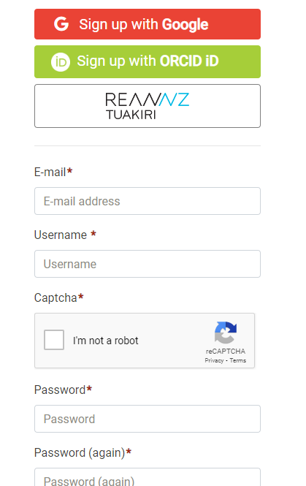
- Whatever email address you sign up with it is important that you do not change from that original sign up email address otherwise it causes problems further down the track

(this is what you will see when you sign in or log in)

Creating a Profile in the portal
Every person no matter if you are an applicant or referee (this is unless you have registered through the portal in the last two years) has to create a profile and must input at a minimum of the following:
- Name
    - Contact email address
- Primary place of employment or education
- Have written an ethics statement, or noted why one is not required.
- You have accepted the Prize Terms and Conditions
- Agree to the Privacy statement for the application process to be available to you.
Other questions that are asked for making a profile are optional and if you do not wish to answer then please press ‘next’.

THE FOLLOWING ARE THE HEADINGS YOU WILL SEE IN THE PORTAL TO CREATE YOUR PROFILE
Organisation (compulsory)
You will need to input your primary organisation, and optionally any others that you are associated with. If it does not auto populate then you can just enter your organisation manually. You are able to enter your position/job title and dates, please add a new entry for each organisation and role.
NB: Can be imported from your ORCID record if you already have one.
Career Stage (optional)
Please select the research career stages that apply to you, and when you think they first applied. If not applicable or you do not wish to answer please leave blank or select Not Applicable.
Academic Record (optional)
Please enter your qualifications and course of study. NB: Can be imported from your ORCID record if you already have one.
Prizes and/or Medals (optional)
You have the opportunity to enter information about Prizes or Medals you may have won. If this is not applicable then just click on ‘next’. NB: Can be imported from your ORCID record if you already have one.

Professional Bodies (optional)
You can enter any professional bodies that you belong to. If you don’t belong to a professional body please just click on ‘next’.

Protection Pattern (compulsory)
You control how your information can be used by specifying the protection to be applied to your data. By default your demographic details (gender, ethnicity, and iwi) and birth date are kept private.
If you are comfortable with sharing this information with the Ministry of Business Innovation and Employment, you may do so by de-selecting the tick box for the protection you wish to relax, or by toggling ‘no protection needed’.
Once all of these steps have been completed you will then be able to click on ‘Apply Now’

IMPORTANT
All applications must be fully complete before it can be submitted. You will not be able to submit the application if there are steps that still need to be completed. i.e.
- Outstanding referee reports
- Missing documents/actions
- Curriculum Vitae’s
- Application Templates
- Ethics statement
- Terms & Conditions

If you have not submitted your application by the due time on the due date it will not be eligible for judging. Please do not leave uploading your application to the last minute. It would be wise to have all documentation uploaded at least 2 hours before closing as sometimes things can go wrong or take time to upload.
It would also be prudent to advise your referee that the referee reports are required at least 12 hours before the process closes. If referee reports have not been received then that will prevent you from completing your application.
APPLICATIONS CLOSE AT 1:00PM ON 5 SEPTEMBER 2023

Checklist
- The referees have completed all that is required including completing the referee template and CV.
- The applicant has uploaded their application including evidence portfolio and CV.
- The applicant has uploaded a plan and expenditure.
- I have accepted the Prize Terms and Conditions.

Need help? Have other pātai questions?
Ko te Kaiwhakahaere the Secretariat for The Prime Minister’s Science Prizes is Royal Society Te Apārangi. Contact details are:
Te Kaiwhakahaere the Secretariat
The Prime Minister’s Science Prizes
Royal Society Te Apārangi
PO Box 598
Wellington
Waea telephone: (04) 470 5762
Īmēra email: pmscienceprizes@royalsociety.org.nz

